Database**: HR**

1. Display the employee First Name, count of characters in the first name, Hire Date in "September 15, 2017", Password.

Password Should be first 4 letters of first name in lower case and the date and month of Hire Date. (6 marks)

Example: First Name - Steven, Hire Date - May 15th then password should be stev1505 .

2. Display the employees who is earning the 2nd highest salary and 2nd lowest salary in each department (8 marks)

3. Display the employee details along with their experience. experience should be in the "3 years and 10 months" format. (6 marks)

Sample output:

* 35Years 1 Month
* 33Years 10Months

4.If we join the below two tables Write the query for each type and the count of output records for below (10 marks)

a) A Inner Join B

b) A Left Join B

c) A Right Join B

d) A Full outer Join B

e) A cross join B

. 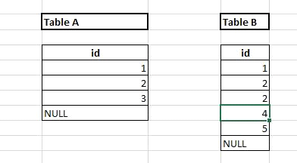

5. Display only the department names Spending greater than 2000 as salary. (8 marks)

6. Display the employees who does not belong to any valid department. (6 marks)

7. Display employee details from employee table along with the email address. (8 marks)

Rules for email:

* first 2 characters of firstname in lowercase followed by @
* @ followed by first 3 characters in the lastname in Uppercase and then "."
* If the employee ID is odd number then append word 'com' after "." otherwise append word 'edu' after "."

Sample data: Employee_id '100' , Firstname 'Steven', Last name 'King'

sample email_id: [st@KIN.edu](mailto:st@KIN.edu)

8. List down the department in which more than 1 employee hired in the same month. (8 marks)

9. Write a query to remove exact duplicates. (Use analytical function) (8 marks)

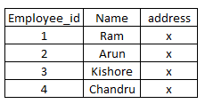**Input Table name: sample**  **Expected Output:**  
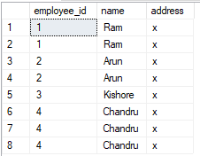

10. Display the Employee ID, Employee Name (first_name +’ ‘ +Last name), Number of character "a" present in the employee first name. (10 marks)

11. Consider the week start from Sunday and ends with Saturday. Display the week start date of hire date for all the employees. (8 marks)

Output: Employee ID, Hire Date, Week Start Date.

Example: If the employee is hired on 12th of April 2021 (Monday), the week start date should be 11th of April 2021.

**Database: Northwind**

12. Display the person details from northwind database. (6 marks)

* Consider Employee ID from employee table & customer ID from customer table as person ID.
* Consider "FirstName LastName" (Concatenated with Space) from Employee table & ContactName from Customer table as person Name
* Employee Flag Should be Set as 1 for Employee and 0 for Customer

**Output**: Person ID, Person Name, EmployeeFlag

13. Display the Order Date, Sale Amount (UnitPrice x Quantity) along with the revenue till date (Running Sum of Sale Amount based on Order Date).

**Output**: Order Date, Sale Amount, Revenue till Date (8 marks)